Overview of labels
Labels are key/value pairs that are attached to objects, such as pods.
It’s used to find out which resource belongs which environment.
Eg: We have a DB with values like below. It will be easy to identify that the DB belongs to Dev environment.
name: tef-db
env:dev
Overview of selectors:
Selectors allows us to filter objects based on labels.
Eg:
- Show me all the objects which has label where env:prod
It will display all the resources which are tagged with PROD environment.
- Show me all the objects which has label where env:dev
It will show all the dev environment resources.
There can be multiple objects within the k8s cluster which we can attach the labels. Some of them are:
- Pods
- Services
- Secrets
- Namespaces
- Deployments
- Daemon sets
Implementing labels and selectors
We have created 3 pods by using.
kubectl run pod-1 --image=nginx
kubectl run pod-2--image=nginx
kubectl run pod-3 --image=nginx

Now if we run kubectl get pods –show-labels we will get
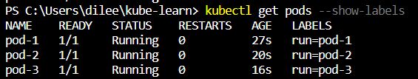
From above SS it’s hard to find out which pod is for which environment. For that we are going to give labels.
Kubectl label pod pod-1 env=dev
Kubectl label pod pod-2 env=stage
Kubectl label pod pod-3 env=prod
Now, If we run kubectl get pods - -show-labels it will show the labels assigned to the pods.
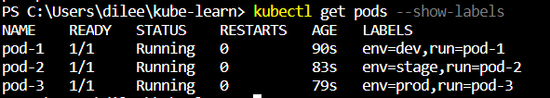
To get the particular label related pods we need to use selector. To specify the selector, we need to specify -l followed by env=dev
Kubectl get pods -l env=dev
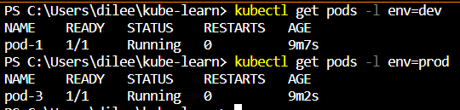
To list the pods which are not related to particular label also we can list it.
Eg: If we don’t want to list dev environment pods, for that we need to use like below.
Kubectl get pods -l env!=dev
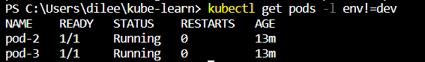
To learn more on this run kubectl label --help
To remove the label we need specify like this
kubectl label pod pod-1 env-
Note:- Labels always need define under metadata in manifests.
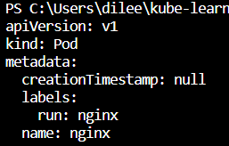
If you want to specify another label like for dev environment, we need to specify like this.
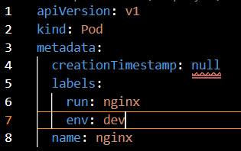
We can do label for all the pods. For that kubectl label pods --all status=running
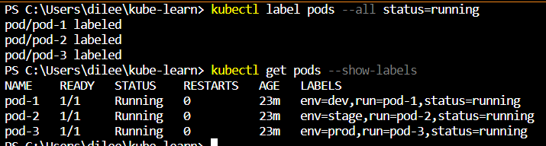

Overview of ReplicaSets
Overview of ReplicaSets:-
A Replicaset is used to maintain a stable set of replica pods running at any given time.
Here two things we need to consider
- Desired state
- Image
Here Desired state=3 & Image = nginx. The replicaset will maintain the desired amount of state. So here replicaset will always maintain 3 pods.
Desired state:- The state of pods which is desired.
Current state:- The actual state of pods which are running.
Eg: While configuring we set the Desired state of the replica set to 3. It will maintain the 3 pods always. If any of the pod gets down the current state will be 2 now RS will try to bring back the pods by creating new pod and make it to desired state after bringing back the current state will become desired state.
Creating our first RS
To get a template of RS and want to know more about RS read this doc ReplicaSet | Kubernetes .
Note:- Don’t make a habit of writing from scratch. Take from doc and do the modifications.
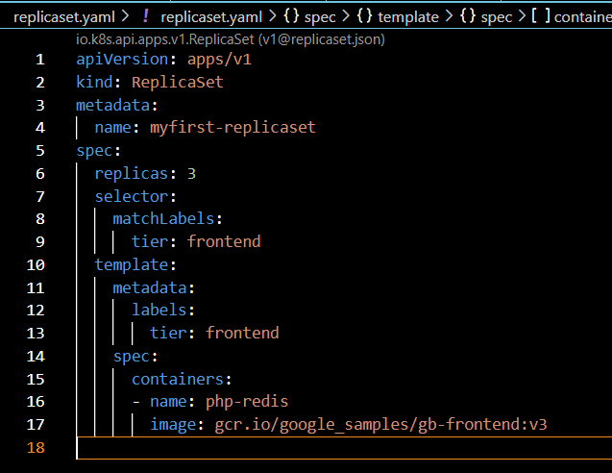
From the template we have removed replicaset label from metadata field.
As we mentioned ‘kind’ for pod we also use here to define the replicaset. Here ‘template’ is nothing but ‘api’ and ‘kind’ in pod.
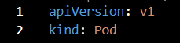 = template
After saving them and run the kubectl apply -f replicaset.yaml command it will create 3 replicasets
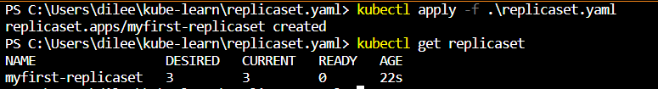
To check the count kubectl get replicaset.
If we try to delete one pod RS will create a new pod to maintain the desired state.
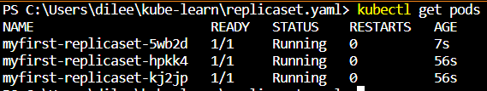
** In below SS we have 2 tier one is matchlabels and another one is labels. The replicaset will always check for the matchlabel name and check for the same label name for pod as well. If it matches it will count it as 1 pod. So if it wants maintain the desired state matchlabels=labels names then all 3 pods should be having same label name. In script if you give diff name it won’t consider it will throw error.
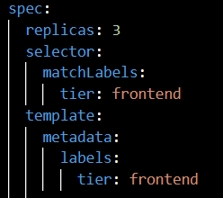
Shortname of ReplicaSet is rs.
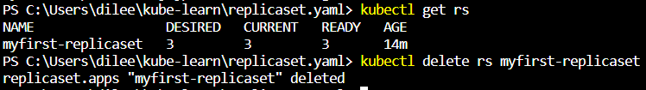
Introduction to deployments
Challenges with RS:-
RS works well in basic functionality like managing pods, scaling pods and similar.
Deployments:- It provides replication functionality with the help of RS, along with various additional capability like rolling out of changes, rollback changes if required.

POD1
Deployment-------- RS--------POD2
POD3
Benefits of Deployments-Rollout changes:-
- We can easily rollout new updates to our application using deployments.
- Deployments will perform update in rollout manner to ensure that your app is not down.
Eg: Let’s assume a service is running with version1 in RS1, Now you have new feature which is version1.1. Here deployment will create a new RS2, after RS2 creates a new pod the deployment will delete RS1 along with the old pod.
- Sometimes, you may want to rollback a deployment; for example, when the deployment is not stable, such as crash looping. Deployment will do that easily.
Creating our first deployment
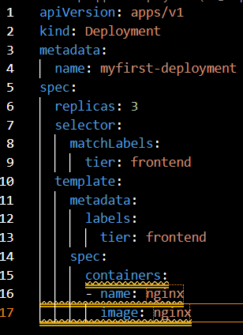
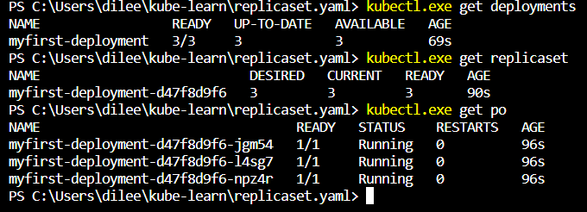
Now for rollout in --image=nginx I have given - -image=1.17.3 after modifying it I have saved it and then I have run apply command. We can observer that the new RS is creating.
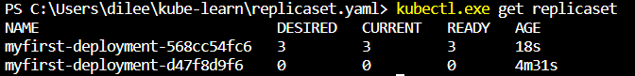
Like this deployment will do rollout.
To know more about our deployment run
Kubectl describe deployments myfirst-deployment
You will get below output. Here we need to events.
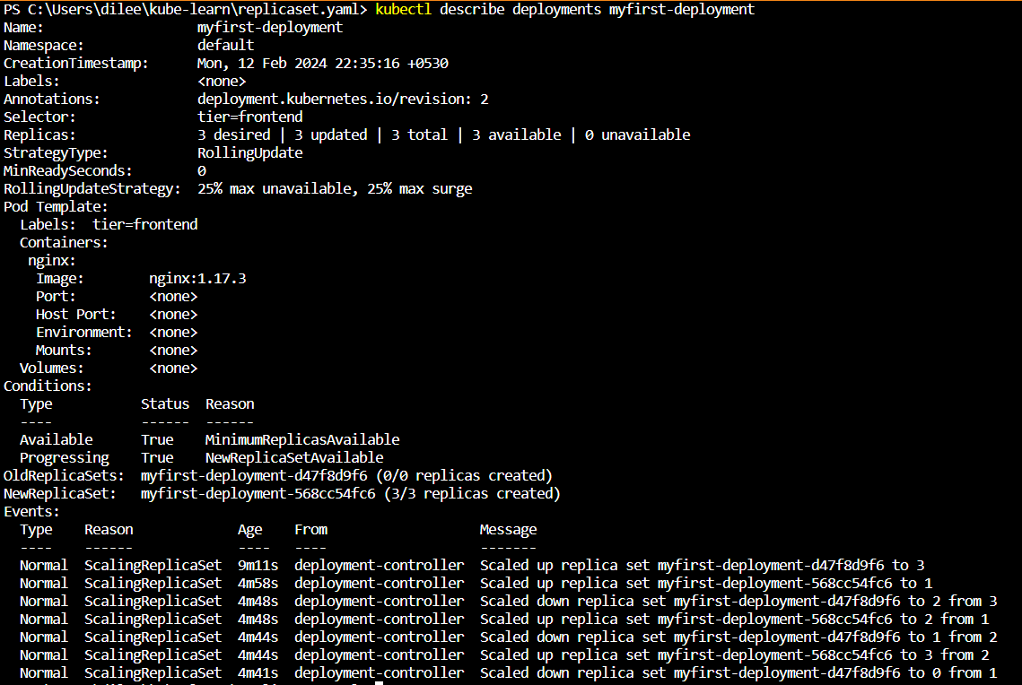
Important Pointers:-
- Deployment ensures that only a certain number of pods are down while they are being updated.
- By default, it ensures that at least 25% of the desired number of pods are up (25%max unavailable).
- Deployments keep the history of revision which had been made.
Rolling back deployments
Deployment will maintain the our deployment revisions accordingly we can roll back.
Kuebctl rollout history deployment.v1.apps/myfirst-deployment
The above command will list the revisions
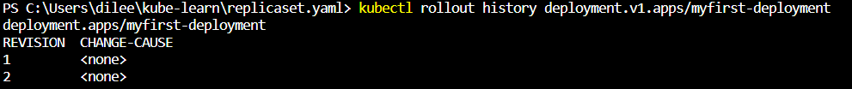
Kuebctl rollout undo deployment.v1.apps/myfirst-deployment - -to-revision=1
The above command will do rollback to revision 1
Now the current revision will become revision 3
Create deployments via CLI
We can run kubectl create deployment set of commands to create a deployment from CLI.

Command | Description
Kubectl create deployment my-dep --image=nginx | Creates new deployment
Kubectl create deployment my-dep--image=nginx --replicas 3 | Deployment with 3 replicas
To get help for deployment kubectl create deployment --help.
Important Pointers-Deployments
4 Important pointers:-
- You should know on how to set a new image to deployment as part of rolling update.
- You should know importance of --record instruction.
- You should know how to rollback a deployment
- You should be able to scale the deployment
Imp commands to remember (Need to check in deep)
Command | Command
Kubectl set image deployment nginx-deployment nginx=nginx:1.91 - - record | Set image
Kubectl scale deployment nginx-deployment --replicas 10 | Scale deployment
Kubectl rollout undo deployment nginx-deployment | Rollout undo

If you want to update the image version we use
kubectl set image deployment nginx-deployment nginx=nginx:1.91 - - record
nginx-deployment is deployment name
nginx is container name
nginx:1.91 is image name
Aftre running above command it will update the image automatically by doing rollout.
record is for identifying it. If we run the command with - - record . When we run kubectl rollout history deployment nginx-deployment in CHANGE-CAUSE you will see kubectl set image deployment nginx-deployment nginx=nginx:1.91 - - record=true
cheat sheet- kubectl Cheat Sheet | Kubernetes
Generating deployment manifests via CLI
Generating deployment manifest via CLI we need use
Kubectl create deployment <deployment name> --image=<image name> --dry-run=client -o yaml

Understanding DaemonSets
Use-Case:
Let’s say that we have three nodes and we want to run a single copy of pod in every node.
Check-> How to create a pod by using RS in each node by using deployments.
Daemon set:- A DaemonSet can ensure that all nodes run a copy of pod.
As nodes are added to the cluster, Pods are added to them.
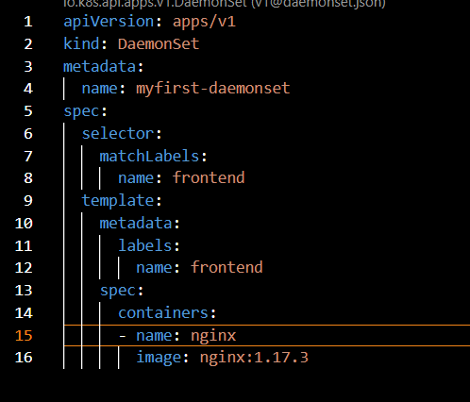
By using above script we will create the Daemonset for nodes. For the pod label which is having ‘frontend’ with the help of selector it will check for the matching pod which is having label frontend and then it will maintain the each pod in each node.
After doing kubectl apply you can see the pods running on multiple nodes.
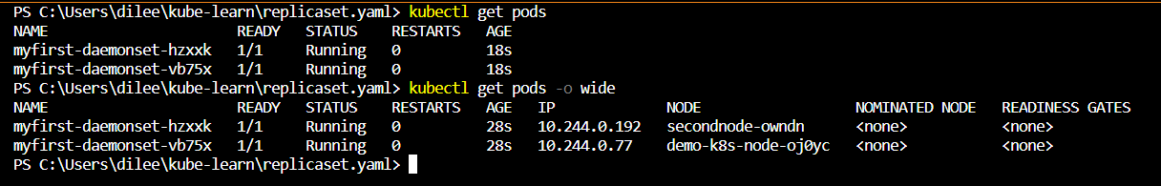
Now, If we add any worker node the DaemonSet will create a new pod to the worker node automatically.
To list down what are all nodes are having for that particular daemon set we need to run
kubectl get daemonset
To get more info like which image it’s using and any error in the logs for the pod you can see it by running.
Kubectl describe daemonset <daemonset name>
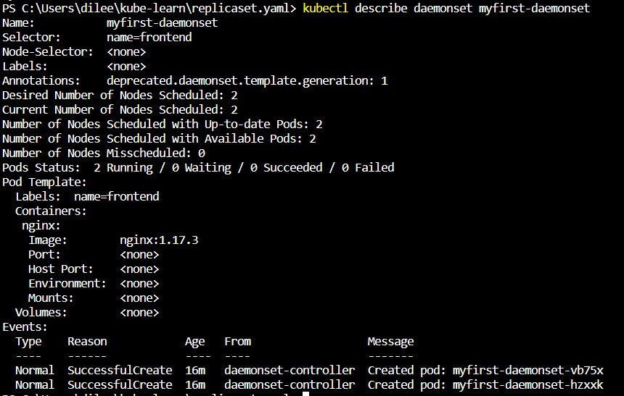
Overview of NodeSelector
Nodeselector allows us to add a constraint about running a pod in a specific worker node.
Use-Case:
- AppA requires faster disk in order to be able run effectively
- Run AppA in nodes which has SSD.
Step1: Add a label to your nodes depending on their disk types.
- disk:hdd
- disk:ssd
Now we have 2 worker nodes node1 is having hdd and node2 is having ssd.
Step2: Create a nodeSelector configuration to run pods only on nodes which has label of disk=ssd that is node2.
By running kubectl describe node <node name>. It will show already prepopulated labels at node level.
- To set up a label for hdd node
kubectl label node <node name> disk=hdd
- To set up a label for ssd node
kubectl label node <node name> disk=ssd
Now we need to create a node selector to which it will help us to run a pod on the worker node having ssd.
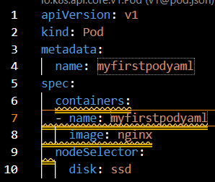
The above script will create a pod on SSD node that is on node 2.
After running apply command you can see the ‘myfirstpodyaml’ pod on node2.
Nodes come pre-populated with the standard set of labels. These include:
- Kubernetes.io/hostname
- Kubernetes.io/os
- Kubernetes.io/arch
- Failure-domain.beta.kubernetes.io/zone
- Failure-domain.beta.kubernetes.io/region
- Beta.kubernetes.io/instance-type
Understanding node affinity
For multiple reasons, there can be a need to run a pod on a specific worker node.
There can be multiple reasons, node hardware being the common one.
Node affinity is a set of rules used by the scheduler to determine where a pod can be placed.
In K8s terms, it is referred as nodeSelector, and node affinity/podaffinity fields under PodSpec.
Affinity at the Node level:-
In K8s, we can achieve nodeAffinity with the help of:
- nodeSelector
- nodeAffinity (more flexibility)
Node affinity is conceptually similar to nodeSelector – it allows you to constrain which nodes your pod is eligible to be scheduled on, based on labels on the node.
S. No | Types | Description
1 | requiredDuringSchedulingIgnoredDuringExecution | Hard Preference
2 | preferredDuringSchedulingIngnoredDuringExecution | Soft Preference
- Preferred means Soft Preference that means even if the constraints can’t full fill still your scheduler can go and place your pod in that specific node
- Required means Hard Preference, basically that means your constraints must match in order to place the pod on that specific node.
To create Hard Preference we will go to our K8s doc Assigning Pods to Nodes | Kubernetes
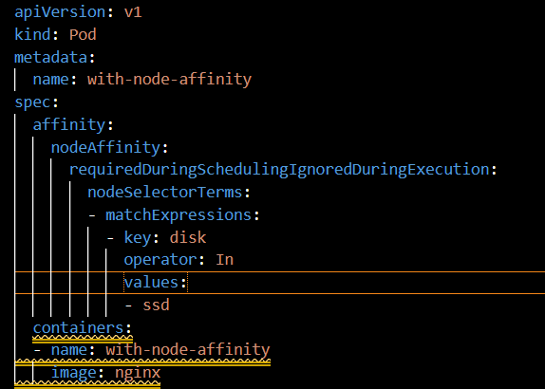
From above script the constraint ‘key:disk’ which is having ‘values is ssd’ it will create the pod in that node that is node 2.You can see the container name ‘with-node-affinity’ on node 2.
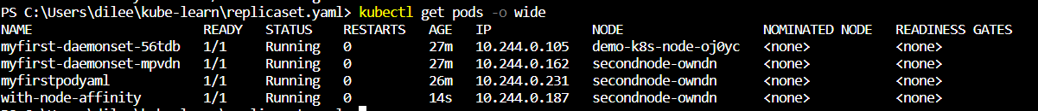
Now If you want to run the pod on the node which is not having ssd disk. All we need to change is operator. This we can get in the above doc.
operator:NotIn
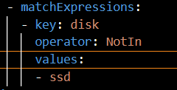
Now it will create a pod on a node which is not having disk ssd that is first node which is having hdd.
To create soft Preference we will go to our K8s doc Assigning Pods to Nodes | Kubernetes
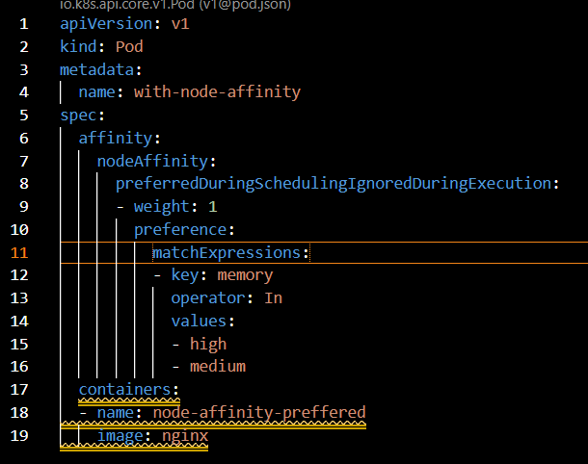
Even though we haven’t attached any node with label of memory but still it will schedule a pod on node.
Note:- Between nodeSelector and nodeAffinity we should opt for nodeAffinity.
Resource Limits
If you schedule a large app in a node which has limited resource, then it will soon lead to OOM (Out Of Memory) or others and will lead to downtime.
Use case: If you have 2 nodes one is having less storage,cpu & ram and another one is having more cpu,storage and ram. Now I have a AppA pod which I need to deploy through Scheduler. Now scheduler will analyze the pod size and specifics it will deploy to the node which is suitable to run the pod without interruptions. Here if node1 is not having enough capacity to run the pod it will deploy on node 2.
Requests and Limits:-
Requests and limits are two ways in which we can control the amount of resource that can be assigned to a pod (resource like CPU and Memory)
- Requests: Guaranteed to get.
- Limits: Makes sure that container does not take node resources above a specific value.

Max Memory Limit(384 MB RAM)

Guaranteed Memory Request (256 MB RAM

From above diagram pod is guaranteed to run with 256 RAM but Max Memory limit of that particular pod is 384 MB. The pod should not take more than 384 MB RAM.
Now we have written a script having resource request as 256 mb memory and ram and resource limit as 512 mb memory and ram.
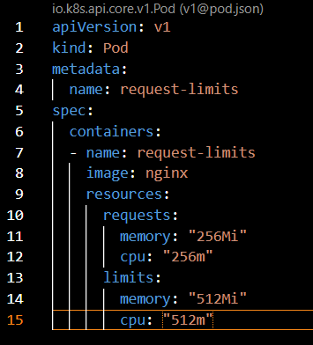
After running the apply command the scheduler will create the pod with mentioned specs.
To check that run kubectl describe node <node name>
Note:-
- K8s Scheduler decides the ideal node to run the pod depending on the requests and limits
- If your POD requires 8GB of RAM, however there are no nodes within your cluster which has 8GB RAM, then your pod will never scheduled.
There are 3 ways to do the requests and limits:
- Guaranteed- Requests and limits are equal
- Burstable- Requests and limits are not equal
- Best effort- No requests and limits have been set
**The Scheduler will always look for resource request not for resource limit. Let’s Assume if you request 512mb memory and limit is 16gb memory (which node is having 8gb). The scheduler will schedule the pod by referring to resource request.
Scheduling pods without a Scheduler
Scheduler is responsible for scheduling a pod on given worker node.
Once node is decided by scheduler, the API server communicates with the kubelet and kubelet in-turn takes care of running the pod.
Understanding static Pods:-
- You can directly inform the kubelet that it needs to run a specific pod.
- There are multiple ways in which you can tell kubelet to run a pod.
- Pod created directly without schedulers are also referred as Static Pods.
To run a static pod write a script yaml file and place it inside /etc/Kubernetes/manifests folder the kuberenetes will automatically runs the pod the instructor shown this through minikube. But, we won’t use static pod extensively.
Taints and Tolerations
Understanding Taints:-
Taints are used to repel the pods from a specific nodes.
For any nodes taint is applied, the scheduler tries to schedule the pod to that node taint won’t allow to schedule the pod to that node.
Understanding Toelrations:-
In order to enter the taint worker node, you need a special pass. This pass is called toleration.
Handson:-
Now we have tainted the node2 by running kubectl taint nodes <node name> key=value:NoSchedule
You can cross verify it by running the kubectl describe node command.
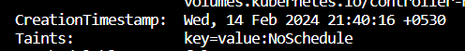
Now we are going run 5 pods let’s see on which node it will get run.
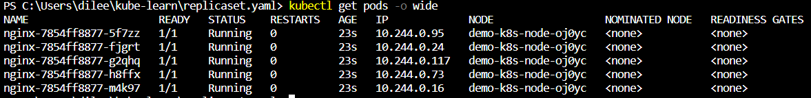
From above SS you can see that all pods are running on node1.Because taint has been applied to it.
Toleration handson:-
To allow a pod to node having taint. We need to give the pass.
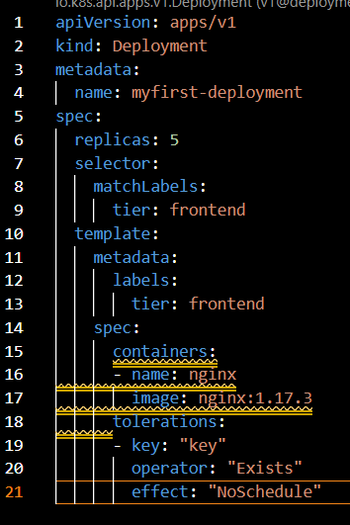
In the above SS, under tolerations we are giving key:”key” . so key is the pass to allow the pods to enter to the tainted nodes.
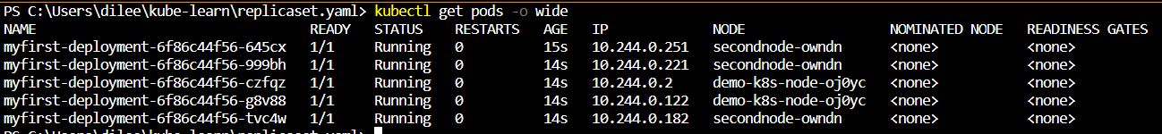
In above SS, you can see that pods get created on node2 as well.
To remove taint

Components of Taints and Tolerations
A taint allows a node to refuse pod to be scheduled unless that pod has a matching toleration. We can apply toleration to a pod within the PodSpec
Components of Taints and Tolerations:-
Parameter | Description
Key | A key is any string upto 253 characters.
Value | The value is any string, up to 63 characters.
Effect | - NoSchedule  - PreferNoSchedule  - NoExecute
Operator | - Equal  - Exist

Kubectl taint nodes <node name> key=value:NoSchedule
Understanding Effects:-
Effects | Description
NoSchedule | New pods that do not match the taint are not scheduled onto that node.  Existing pods on the node remain.
PreferNoSchedule | New pods that do not match the taint might be scheduled onto that node, but the scheduler tries not to.  Existing pods on the node remain
NoExecute | New pods that do not match the taint cannot be scheduled not that node.  Existing pods on the node that do not have a matching toleration are removed.
Understanding Operator:-
Operator | Description
Equal | The key/value/effect parameters must match. This is the default.
Exists | The key/effect parameters must match. You must leave a blank value parameter, which matches any

Multi-Container POD Design patterns
Sidecar pattern is nothing but running multiple container as part of a pod in a single node.
Ambassador pattern is a type of sidecar pattern where the second container is primarly used to proxy the requests.
Adapter Pattern is generally used to transform the app output to standardize/normalize it for aggregation.
Adapter Pattern
Adapter Pattern is generally used to transform the app output to standardize/normalize it for aggregation.
**Usually they say Multi-Container POD is not important. But Zeal vora is mentioning that it’s important need to google it.

